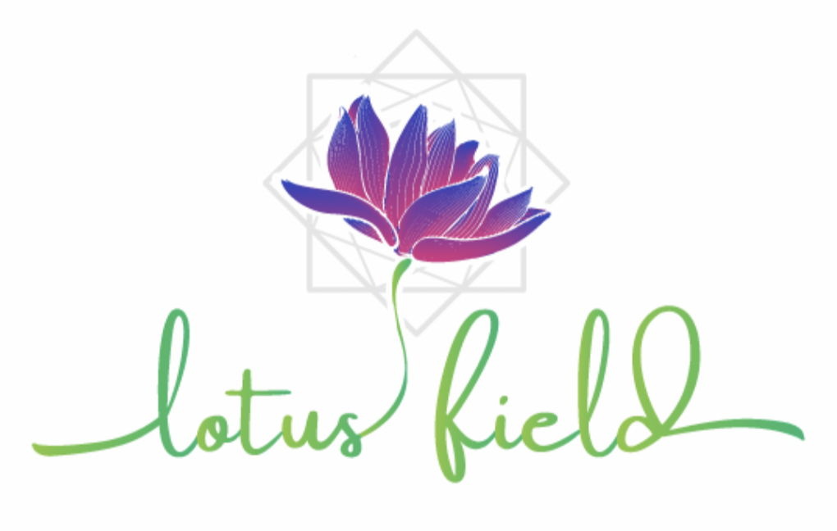

Buccal Face Massage

Client Intake Form

|  |  |  |  |
| --- | --- | --- | --- |
| Full Name: |  | | |
| Mobile: |  | | |
| For women: are you pregnant?  (if YES – how many weeks?) | |  | |
| Known allergies: (please list) | |  | |
| Please list any medications, supplements or alternative remedies you are taking that may affect the session: | |  | |
| Do you experience any body pain that I need to be aware of? | |  | |
| Are you comfortable with having intraoral (buccal) procedure? (i.e., practitioner working inside the oral cavity wearing sterile gloves? | | | YES  NO |

Intentions

|  |
| --- |
| What are your main intention/s for receiving a buccal face massage or what do you hope to experience from it? (e.g., relaxation and self-care, jaw tension, TMJ support) |
|  |

Focus Areas

|  |
| --- |
| Are there any areas of the face/upper body that you would like to receive more focus? |
|  |

Contraindications & Risks

|  |  |
| --- | --- |
| ABSOLUTE (tick as applicable) | RELATIVE (tick as applicable) |
| Systemic contagious or infectious diseases, including the common cold, flu and COVID and 7 days after | Clients of 60+ years of age and/or with known conditions affecting bone health (osteoporosis, osteopenia etc.) |
| COVID vaccination – 14 days after | Excessive emotional excitability |
| Acute conditions requiring first aid or medical attention | Spinal disk hernias, bulging, thinning or degenerative discs (especially in the neck) |
| Acute pain anywhere in the body | Pregnancy II trimester |
| Severe unstable hypertension | Post-cancer or cancer in remission |
| Fever | Managed thyroid conditions |
| Nose bleeding | Mild rosacea |
| Epilepsy | Plastic surgery – please list procedure/s & date/s |
| Recent operations including plastic surgery or acute injuries | Mesothreads and threadlifting – not earlier than 3 months post procedure |
| Benign tumors and various cancers | Botox – not earlier than 5 weeks post injection |
| Serious nervous or psychotic conditions | Fillers – not earlier than 12 weeks post injection |
| Herpes in acute stage | Other facial procedures, e.g., peels, needling |
| Under the influence of drugs or alcohol, including prescription pain medication | Dental Conditions (Pulpitis, Stomatitis, Paradontosis, Mouth Ulcers, Dental Implants, Brackets) |
| Heart problems, angina, those with pacemakers | Please provide details for any selected conditions: |
| Bleeding of the gums, mouth ulcers, braces |  |
| Pregnancy I and III trimester |
| Unmanaged thyroid dysfunction |
| Autoimmune thyroid dysfunction |
| Pathologies of lymphatic system including inflammation of lymphatic nodes |
| Damaged lymphatic vessels |
| Acute rosacea and couperose, skin inflammation, severe acne |
| Open cuts and wounds, and local inflammation of the skin |
| Psoriasis, neurodermitis, eczema |
| Sunburn |

Client Waiver

Please read carefully and sign:

1. I have stated all my known conditions and have answered all questions honestly. I take it upon myself to keep the Practitioner updated on my health.
2. I understand that the Practitioner does not diagnose, prevent or treat illness, disease or any other physical or mental conditions.
3. I understand that this treatment is not a substitute for medical treatments and/or diagnosis, and it is recommended that I see a qualified professional for any physical or mental condition that I may have.
4. The Practitioner has provided and explained the safety issues surrounding my session. I have had the opportunity to ask any questions.
5. I indemnify and hold Rachel Frost harmless for any injuries or negative effects I may experience as a result of having the treatments done on me or using the products I receive during this consultation.

Full Name:  
  
Client Signature:

Today’s Date: / /